Comprehensive User Testing

This document shows outputs from valid and invalid inputs

# Main Menu

Prompts for a new input until a valid input is entered

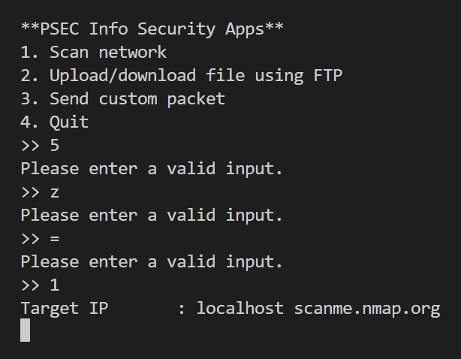

# Nmap Scanner

Option 1 of the main menu displays a scan of the top 10 ports (TCP & UDP) of localhost and scanme.nmap.org each.

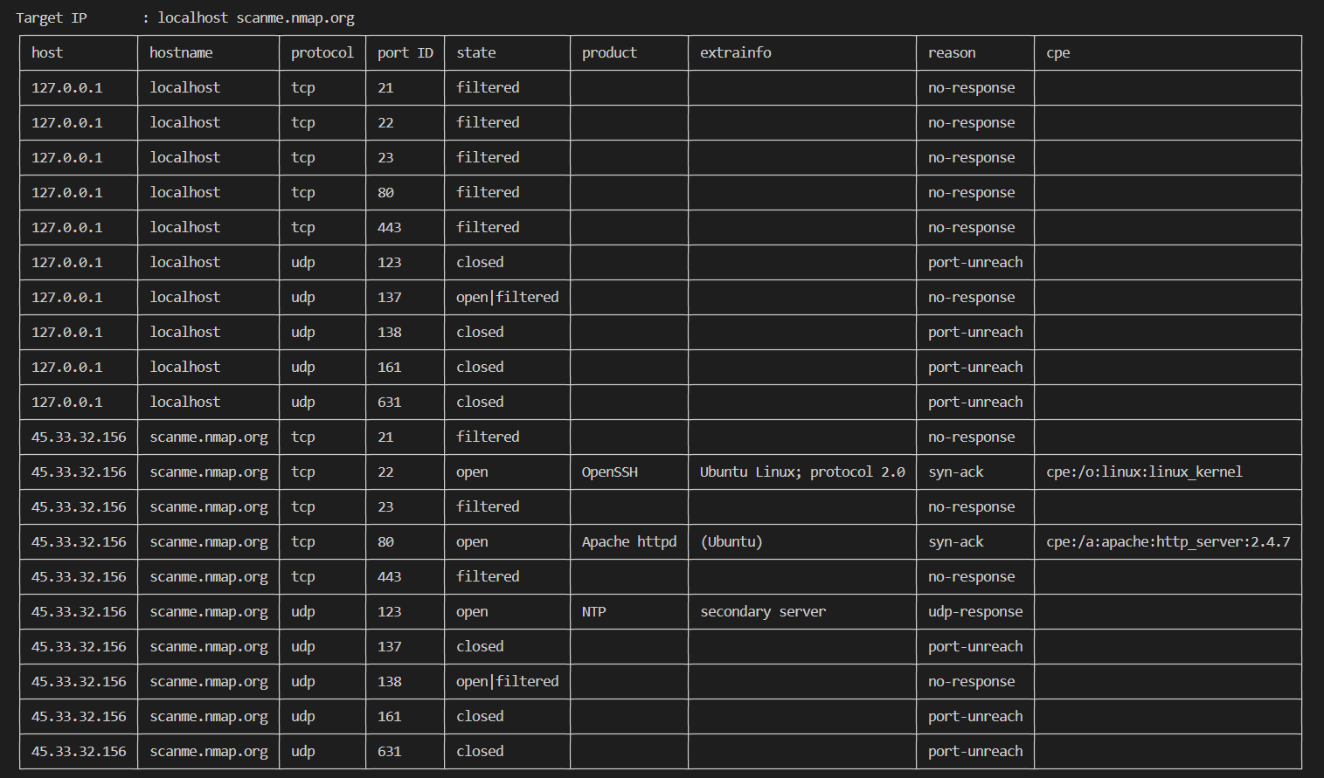

# Upload/download file using FTP

Option 2 of the main menu allows the user to upload or download files from the server via FTP.

If server is not running:

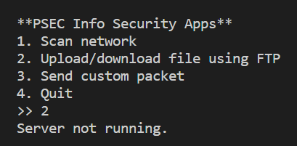

If server is running:

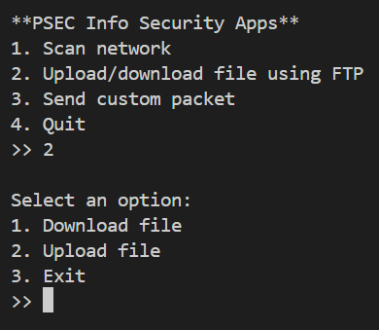

Invalid input for upload/download menu:

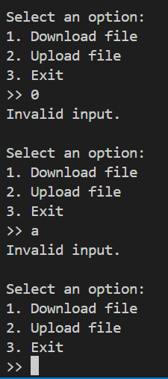

Input 1 (download):

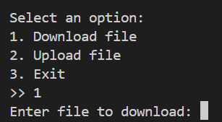

Invalid input for download file:

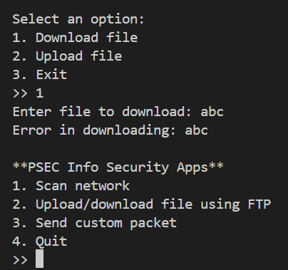

Valid input for download file:

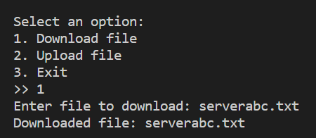

Before download:

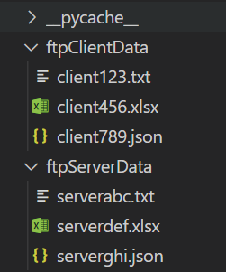

After download:

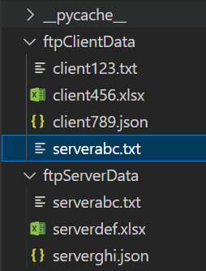

Input 2 (upload):

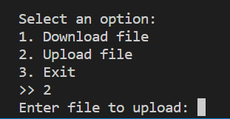

Invalid input for upload file:

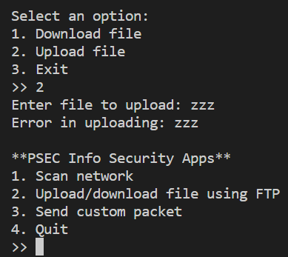

Valid input for upload file:

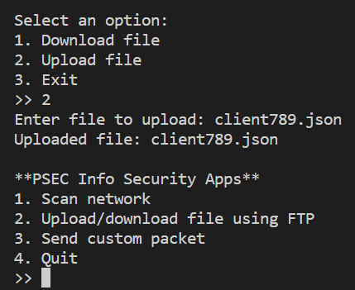

Before upload:

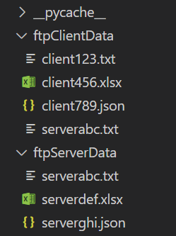

After upload:

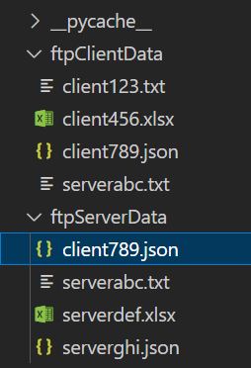

Input 3 (exit):

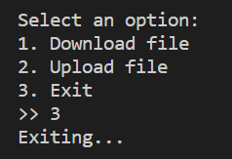

# Custom Packet

Option 2 of the main menu allows the user to upload or download files from a the server via FTP.

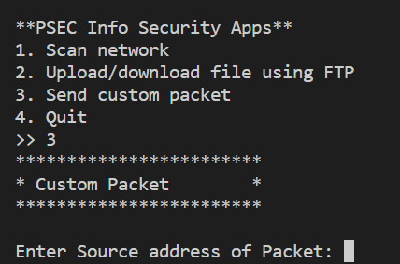

Invalid source address:

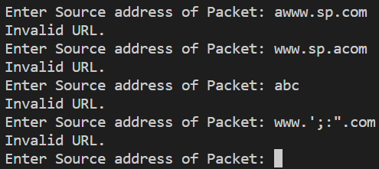

Valid source address:



Invalid source port number:

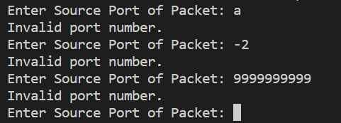

Valid source port number:



Invalid destination address:

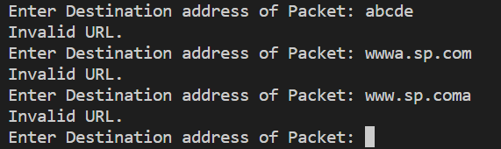

Valid destination address:



Invalid destination port number:

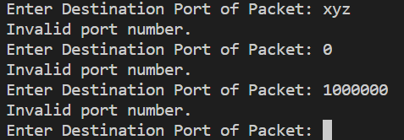

Valid source port number:



Invalid packet type:

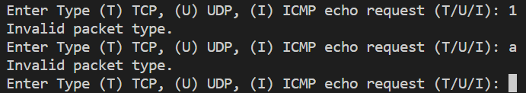

Valid packet type:



Raw data (no validation required)



Invalid number of packets to send:

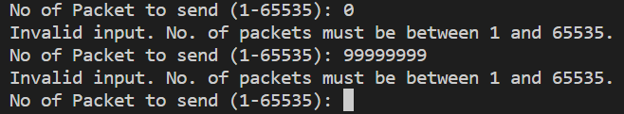

Valid number of packets to send:



Confirm start:



Wireshark capture TCP:

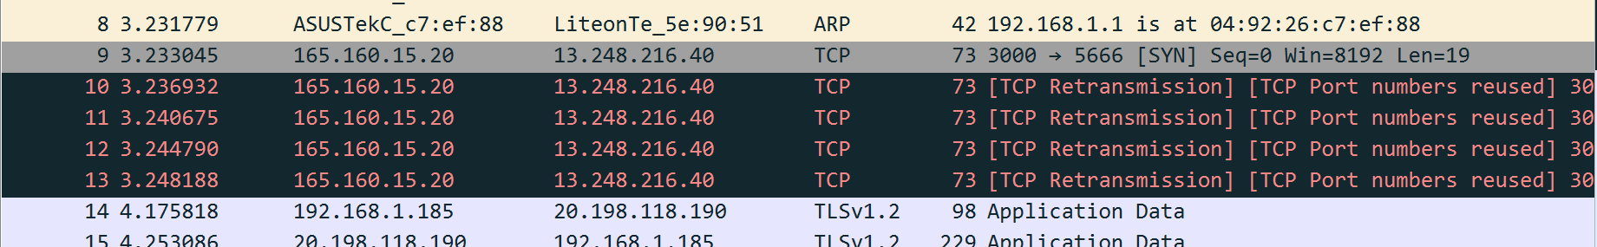

Wireshark capture UDP (DIS uses UDP):

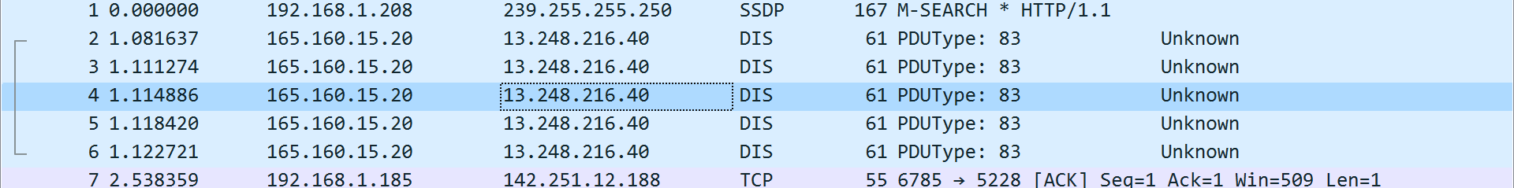

Wireshark capture ICMP

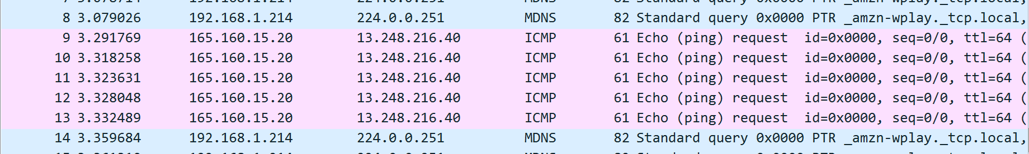

Abort start:



# Quit

Option 4 of the main menu closes the program

